Submissions to www.tci-thaijo.org
For registered authors who have submitted their articles and requested to have the articles published in NIDA journals, due to NIDA Development Journal (NDJ) and NIDA Case Research Journal being publications indexed under the Thai Journal Citation Index Centre, it is a requirement that you also submit your articles via the TCI Thai JO system before your submissions can be proceeded to the next step.
Authors who wish to have their article published in the NIDA Development Journal (NDJ) can submit the articles via the link below:
https://so04.tci-thaijo.org/index.php/NDJ
Authors who wish to have their articles published in the NIDA Case Research Journal can submit the articles via the link below:
https://so04.tci-thaijo.org/index.php/NCRJ
Authors may refer to the short version manual in the attachment and download the complete manual by following the instructions in the attachment. If you have any problems with any of the steps, please send your inquiry to this email or contact the Admin of our Facebook Page: Research Center at NIDA for a quick response.

Steps for submissions to www.tci-thaijo.org
1. Go to the journal’s website you wish to submit your article.
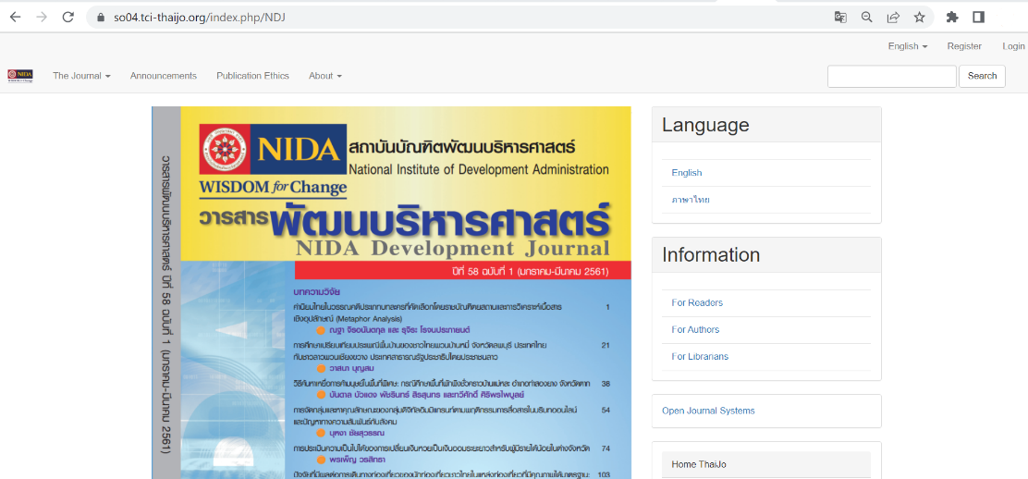
NIDA Development Journal: https://so04.tci-thaijo.org/index.php/NDJ

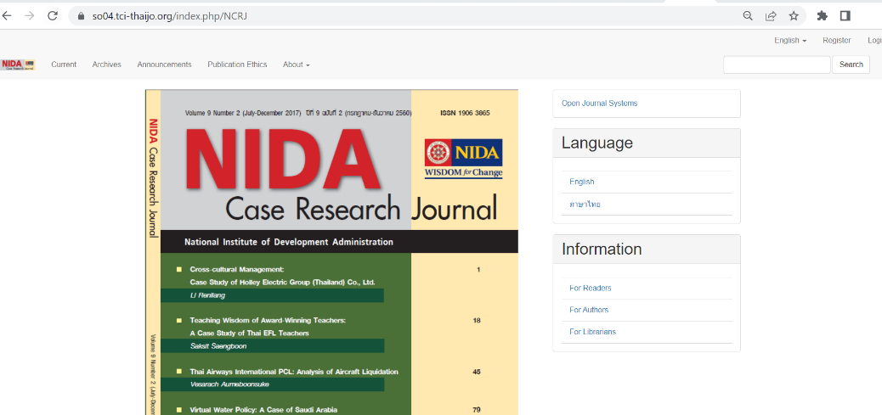
NIDA Case Research Journal: https://so04.tci-thaijo.org/index.php/NCRJ

2. If you are not a member of Thaijo, follow the registration steps by referring to the Thaijo manual: steps for registration.
URL: https://drive.google.com/file/d/10joqVtkdpt1tofucELcutsCn4SoYG2_3/view?usp=sharing

3. If you are a member of Thaijo, follow the steps for submission.
URL: https://drive.google.com/file/d/1U3p3A20G4UX2PG_6llAi44B6I5y6xZkI/view?usp=sharing

*Steps for authors can be found at: https://drive.google.com/file/d/1ViMAboke_OZ9oUnDurklEiKWJBWEnenA/view?usp=sharing

**Complete version of the Thaijo manual can be found at:
https://drive.google.com/file/d/1FHf1iGGokeJUTDWKaSvuKZfH1TC1omRc/view

Documents to be submitted to the Thaijo system are as follows:
1. Microsoft Word and PDF files of the manuscript.
2. Article Submission Form
NIDA Development Journal Article Submission Form
: https://drive.google.com/drive/folders/1bzs0BMillDRdL44B4UDWZDvmEnVutwlG?usp=sharing
NIDA Case Research Journal Article Submission Form
: https://drive.google.com/drive/folders/1MS9JRvtd_WylLiqk72Ll5RP0_CqFGGRa?usp=sharing

For queries or additional information, please contact 02-727-3314 , 02-727-3312 or
Email : journal@nida.ac.th , Facebook Page : Research Center at NIDA



SCAN ME

